Use Case - Document

Module Name:Modify Policy

Use Case Name: Policy modification as per request

# ID:103

# Name:Modify Policy

# Title:

Policy modification as per request.

# Description:

Admin has his own dashboard through which he can see the updates of policy holder and agent. Admin can track the activities of agents and policy holder. When agent/policy holder will request for modification in personal details or policy details then admin should be able to accept those requests and work on it.

# Use Case Diagram:

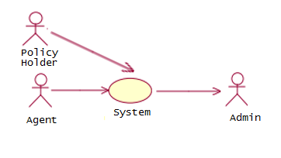

# Pre-Conditions:

1. Admin should be logged in the system.
2. Admin should have his own dashboard.
3. Admin should be able to check the details of agents and policy holder.
4. Admin should be able to see all the requests by policy holder and agents.

# Post-Conditions:

1. If policy holder/agent will request the admin for modification of details then admin should accept those requests and grant permission to do changes.
2. After completing modification policy holder/agent should submit the details to save it in database permanently.

# Primary Flow:

1. Admin will log in into the system
2. Admin will check for the requests from policy holder and agents.
3. Admin will check the login credentials about agents and policy holder.
4. If login credentials are correct then admin will grant the permission to modify the details.
5. After modifying details policy holder and agents should submit the details to store it permanently in database.

# Alternate Flow:

1. Login credentials are not correct
   * If login credentials are not correct then admin will ask policy user and agent to provide correct login credentials.

# Data:

1. Agent login credentials
2. Policy holder login credential.